Parade Invitation
The New Market 4th of July Committee is excited to announce the 2024 4th of July parade. We would like to take this time to personally invite you to participate in one of the biggest celebrations in SW Iowa! The parade is scheduled for Thursday, July 4th at 1:00 pm.
The celebration theme this year is, “What a Small Town Should Be!” We invite all to take part in our parade and show off your business or organization at this largely attended event. We are looking for entries of all kinds but this year our emphasis is on floats! Individuals, Families, Businesses, Organizations, Churches, and Schools. The sky’s the limit. Your imagination and creativity will make the parade a continued success!
There is no registration needed! The line-up is along 1st Street (old Highway 2) and is first come, first on the route. We look forward to seeing you there!
If you have questions or need more information email rseela@seelascience.com, or call Rozann at 402-658-4456.
Just a reminder that 4-wheelers are only allowed if they are part of a float, and no alcohol can be consumed or distributed while on the parade route. Let’s make it a fun and safe parade for all!
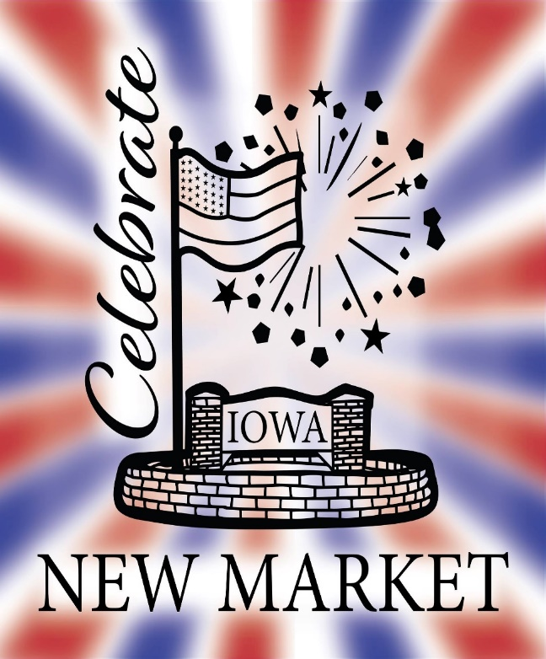
We had so much fun with all the floats last year that we are continuing the “Best of Show” cash prizes to the top 4 floats!
1st Place - $400.00
2nd Place - $300.00
3rd Place - $200.00
4th Place - $100.00
Come and join in on the fun!

